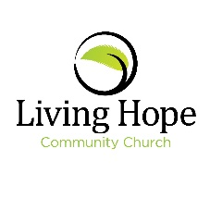
Living Hope Community Garden
16607 E. Broadway Ave.
Spokane Valley, WA. 99037
(509) 924-9775

Dear Friend,
Over the past year we at Living Hope Community Church have been collaborating on how our church could better serve our community in Spokane Valley. Our church has been blessed with a large portion of land on the church property which is currently vacant. We have chosen to use this land to provide a community garden that will bring people together to grow their own food, to cultivate relationships with others in the area, and also to meet members of the Living Hope Community through a common interest of planting and tending their gardens.
We will be organizing workshops at the church to foster these relationships while teaching about the basics of growing food, as well as fun craft projects for the children and adults alike. Our goal is to provide a safe and healthy place for the community to gather and build relationships while providing food for themselves and to those less fortunate through Valley Partners, the local food bank. We hope these new friends will bring other friends along to learn about growing sustainable, healthy food. We also want to provide a children’s garden with an interactive full sensory space for children in foster and adoptive families to learn while easing anxiety through the power of gardening.
Living Hope Community Church has developed a design and management plan for the Community Garden and have identified materials needed in order to launch in the Spring of 2020.
We are asking your organization to help us by gifting any items you can provide. A list is attached of needed building materials. If you would prefer to donate by sending a check, please make it out to Living Hope Community Church. We are including a community bulletin board in the garden and will express our gratitude to all of those who have contributed to the creation of our project.
We greatly appreciate your consideration and please feel free to call me if you have any questions about our endeavor.

Sincerely,
Mike Szott
Living Hope Community Church
(509) 263-7710

